Operating Systems Lab Environment Setup
Ubuntu, WSL, VS Code & Python
Name:Pankaj Kumar | Roll No: 2401010211 | Section: D
Component | Version / Status
Windows Subsystem for Linux (WSL) | 2.5.9.0 (WSL 2), kernel 6.6.87.2
Ubuntu Linux | 24.04.3 LTS (noble), Running
Visual Studio Code | 1.103.2 (x64), connected via WSL: Ubuntu
Python | 3.12.3 (/usr/bin/python3)
Test program | test_env.py executed successfully
Conclusion: All required components (Ubuntu, WSL, VS Code and Python) are installed, configured and verified. The basic test program ran successfully both from the Ubuntu terminal and inside VS Code connected to WSL.
1. WSL Verification Command: wsl --version
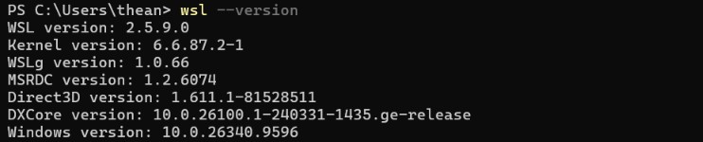
WSL version 2.5.9.0 with kernel 6.6.87.2 is installed on Windows (build 10.0.26340.9596).

Ubuntu running on WSL 2
Command: wsl -l -v
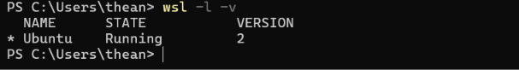
Ubuntu distribution is in Running state and uses WSL VERSION 2.

Ubuntu and Python Verification
Commands: lsb_release -a, uname -r, python3 --version, which python3
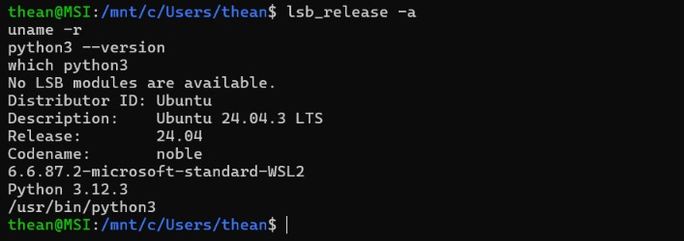
Ubuntu 24.04.3 LTS (noble), kernel 6.6.87.2-microsoft-standard-WSL2, Python 3.12.3 at /usr/bin/python3.

VS Code Verification
Commands: code --version, cd ~/oslab, code .
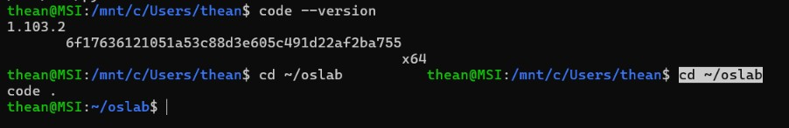
VS Code version 1.103.2 (x64) is installed and launched from the WSL terminal.

Test Program Creation and Execution
Commands: echo ... > test_env.py, python3 test_env.py
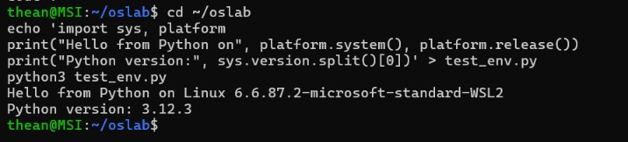
Test script was created and executed in WSL; it printed the OS (Linux WSL2) and Python version 3.12.3.

Test Program in VS Code (WSL: Ubuntu)
VS Code connected to WSL: Ubuntu, running python3 test_env.py
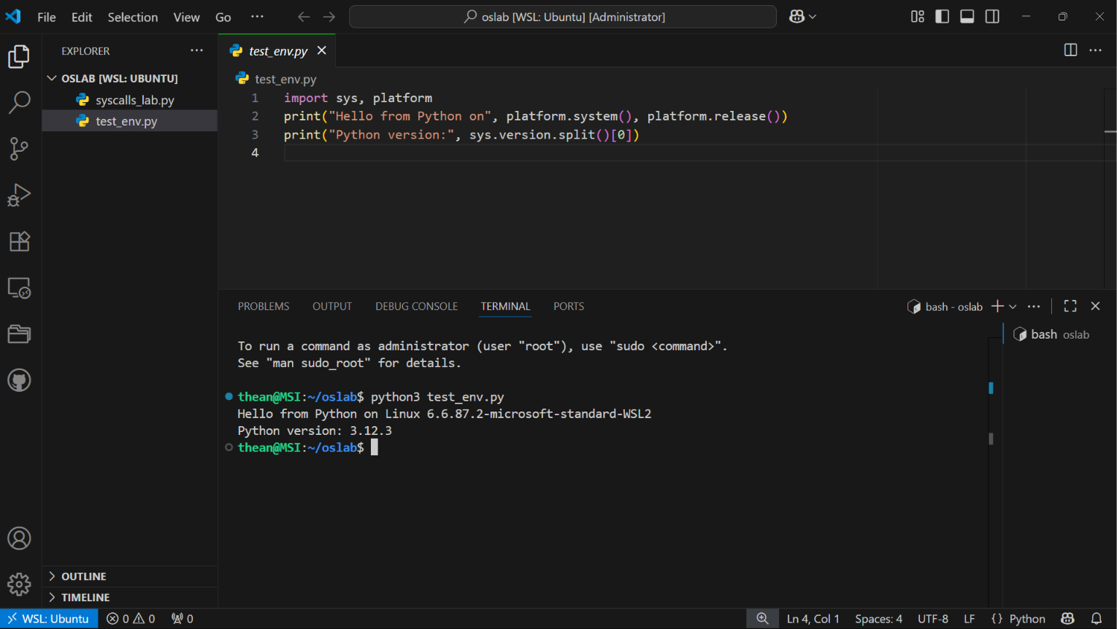
VS Code is connected to WSL: Ubuntu (bottom-left). test_env.py ran successfully in the integrated terminal.

